Waste Management

### PREPARED FOR

Information Technology Institute

### PREPARED BY

Islam Hany

Amal Assad

Aya Hassan

Christine George

# 1. Project overview

Waste Management for ITI building where workers are assigned specific floors to manage waste. Workers have Mobile or Web App where they can see wastebaskets state in real time.

# 2. Technologies Used

* Master Of Things AEP
* NodeJs
* ReactJs
* ReactNative (Cross Platform)

# 3. Technical Obstacles

* Remote work
* Multi user authentication system
* Handle Payment gateways
* Deployment

# 

# 4. Milestones and Reporting

|  |  |
| --- | --- |
| **Milestone** | **Tasks** |
| **1 - Analysis** | |
|  | Analysis and design stage, gather data and create system mockup |
| Architecture design |
| Design work plan (distribution of tasks to development teams) |
| **2 - Development** | |
|  | Create Application Forms (Database) |
| Create Pages for Admin to view all floors |
| Create Sensors for each floor |
| Create Consolidated Sensors to gather the floor's related sensors |
| Create Custom events to publish sensors' data to the mobile and web app |
| Create Web Application with ReactJs |
| Create Cross Platform Mobile Application Using ReactNative |
| Create Web Socket Server Using NodeJs |

**Github :**

<https://github.com/IslamHany/WasteManagementApp.git>

How it works?

* 1. **Admin**

**Home Page**

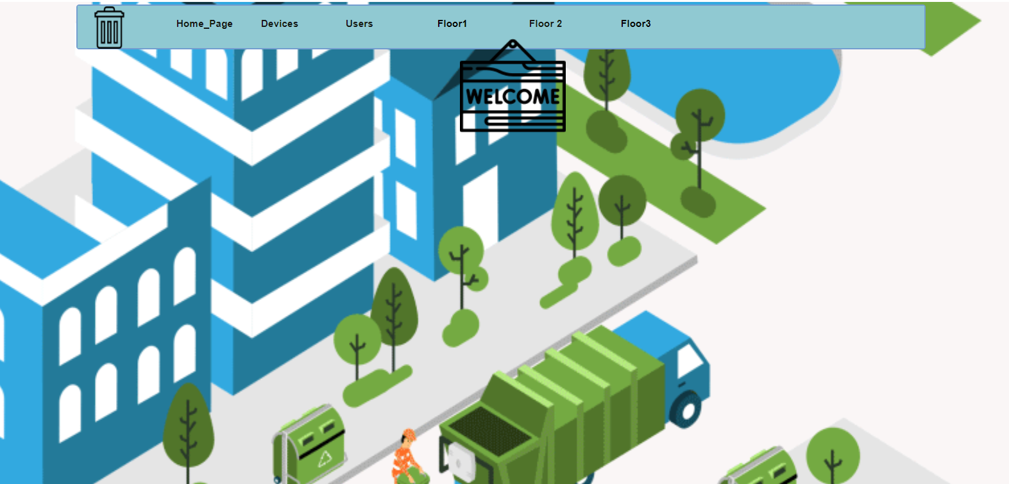

Welcome page for admin with nave bar which you can move to another page

**Devices Page**

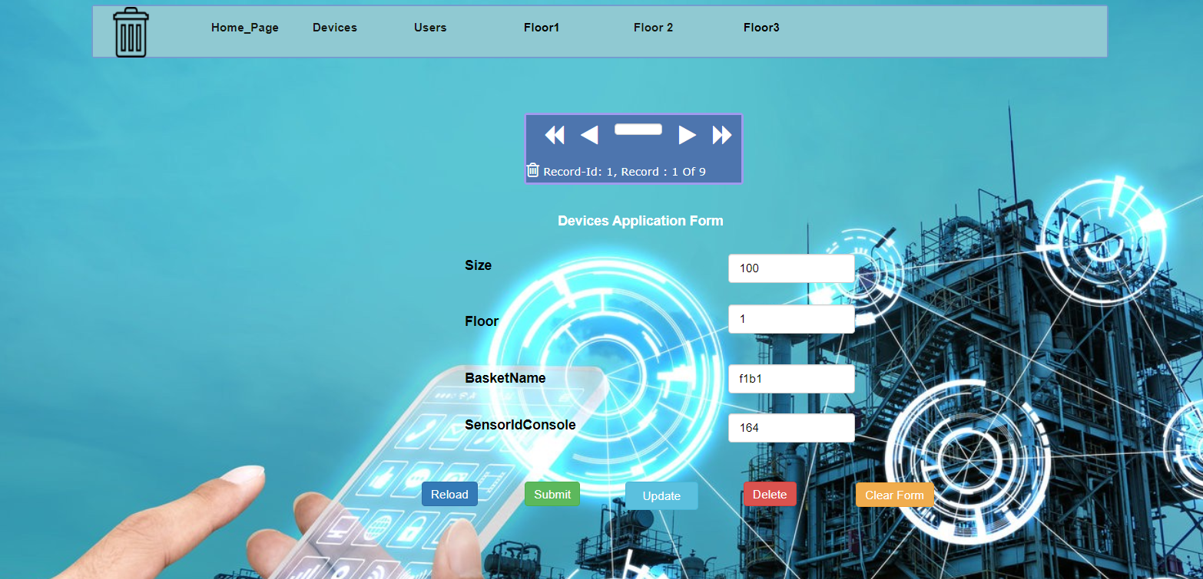

The admin has privilege to add new basket at any floor and record it through devices application form

**Users Page**

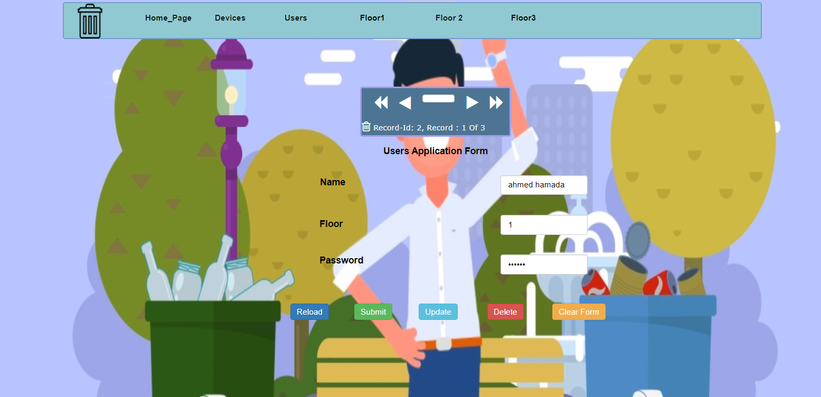

The admin can add any through users application form worker and assign a specific floor for him

**Floor Page**

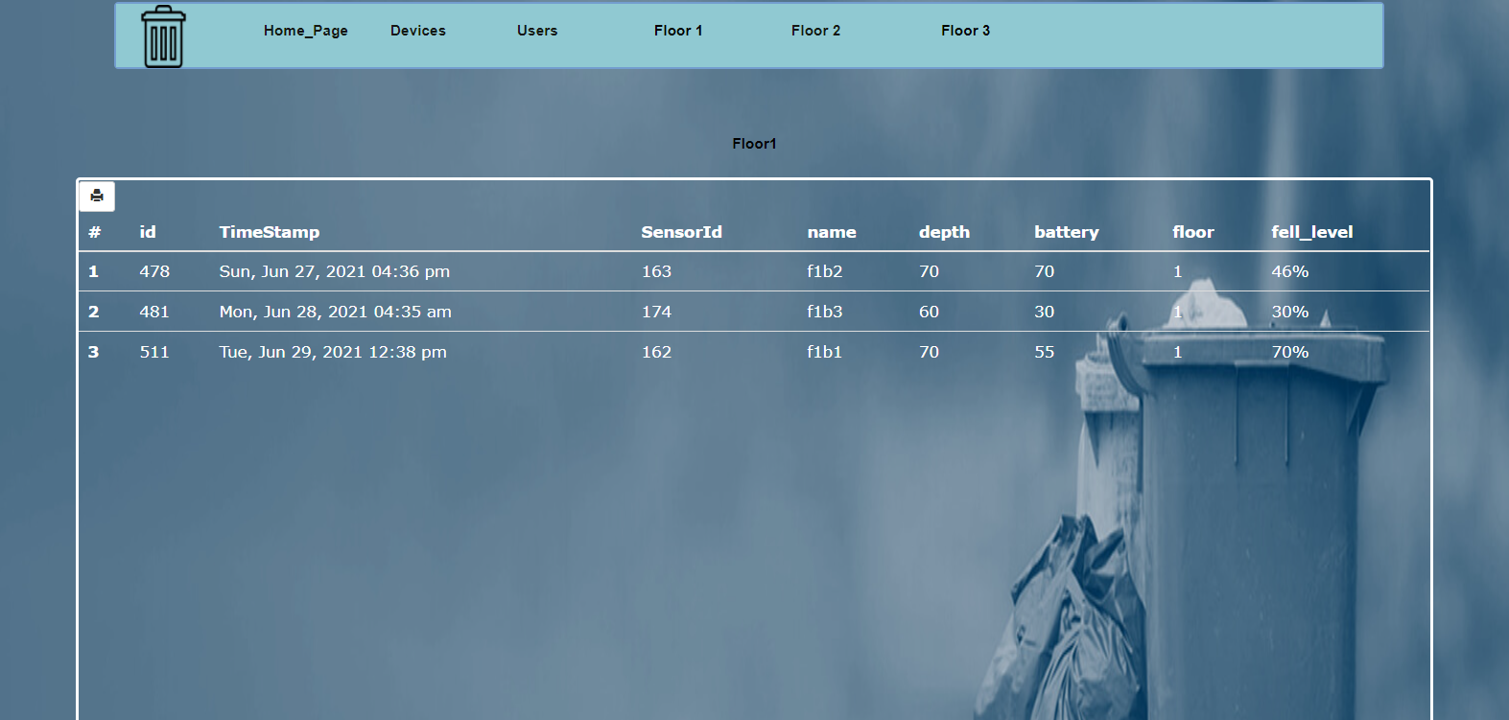

The admin has a privilege to access any floor’s data through floor’s table which has the recent data for any basket

**2-Mobile Application**

**Login**

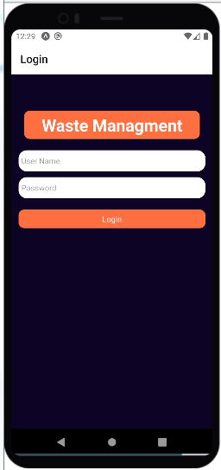

The worker can login with the credentials that the admin assigned to him

**View Baskets' state**

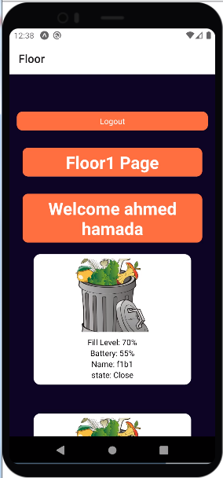

Now after login the worker can view all the baskets that is assigned to him in that floor and view the baskets' state at real time.

**Home Page**

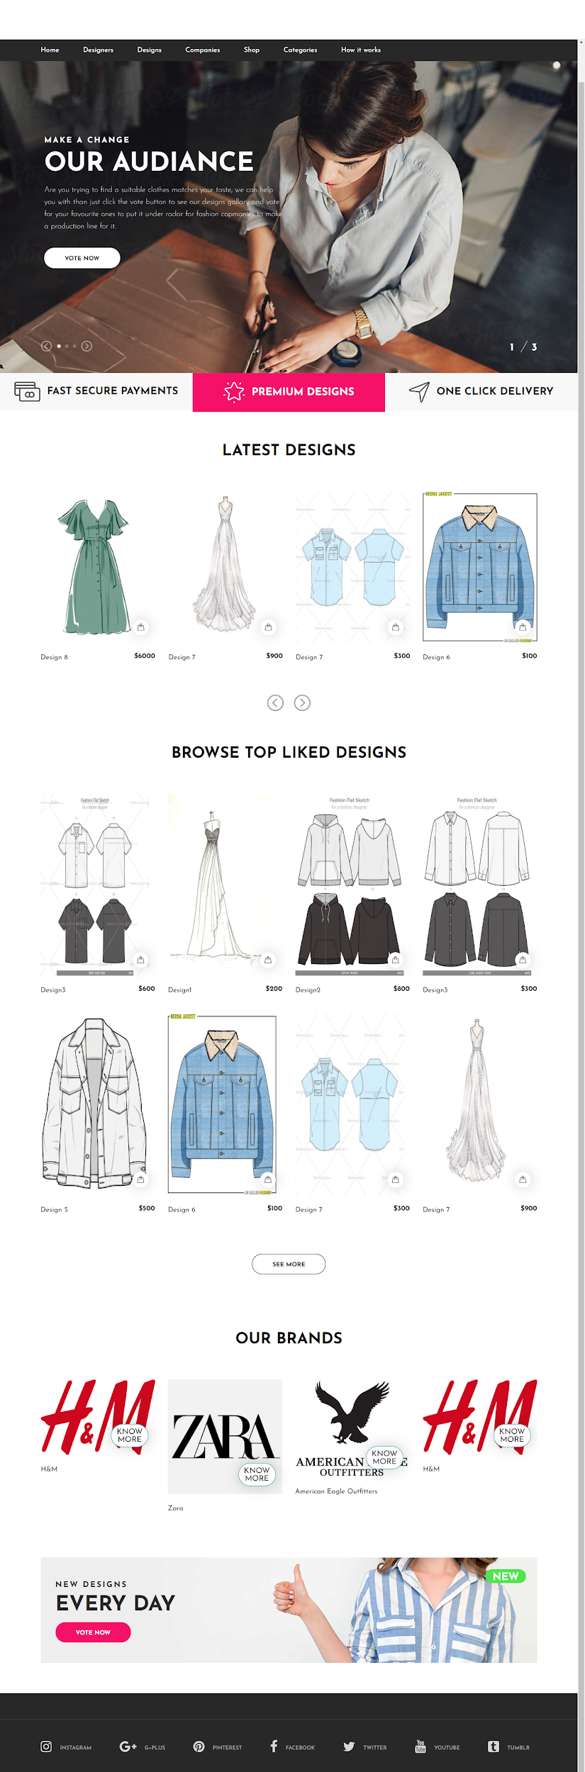  
List top liked designs,Latest designs and Brands

**Add a design**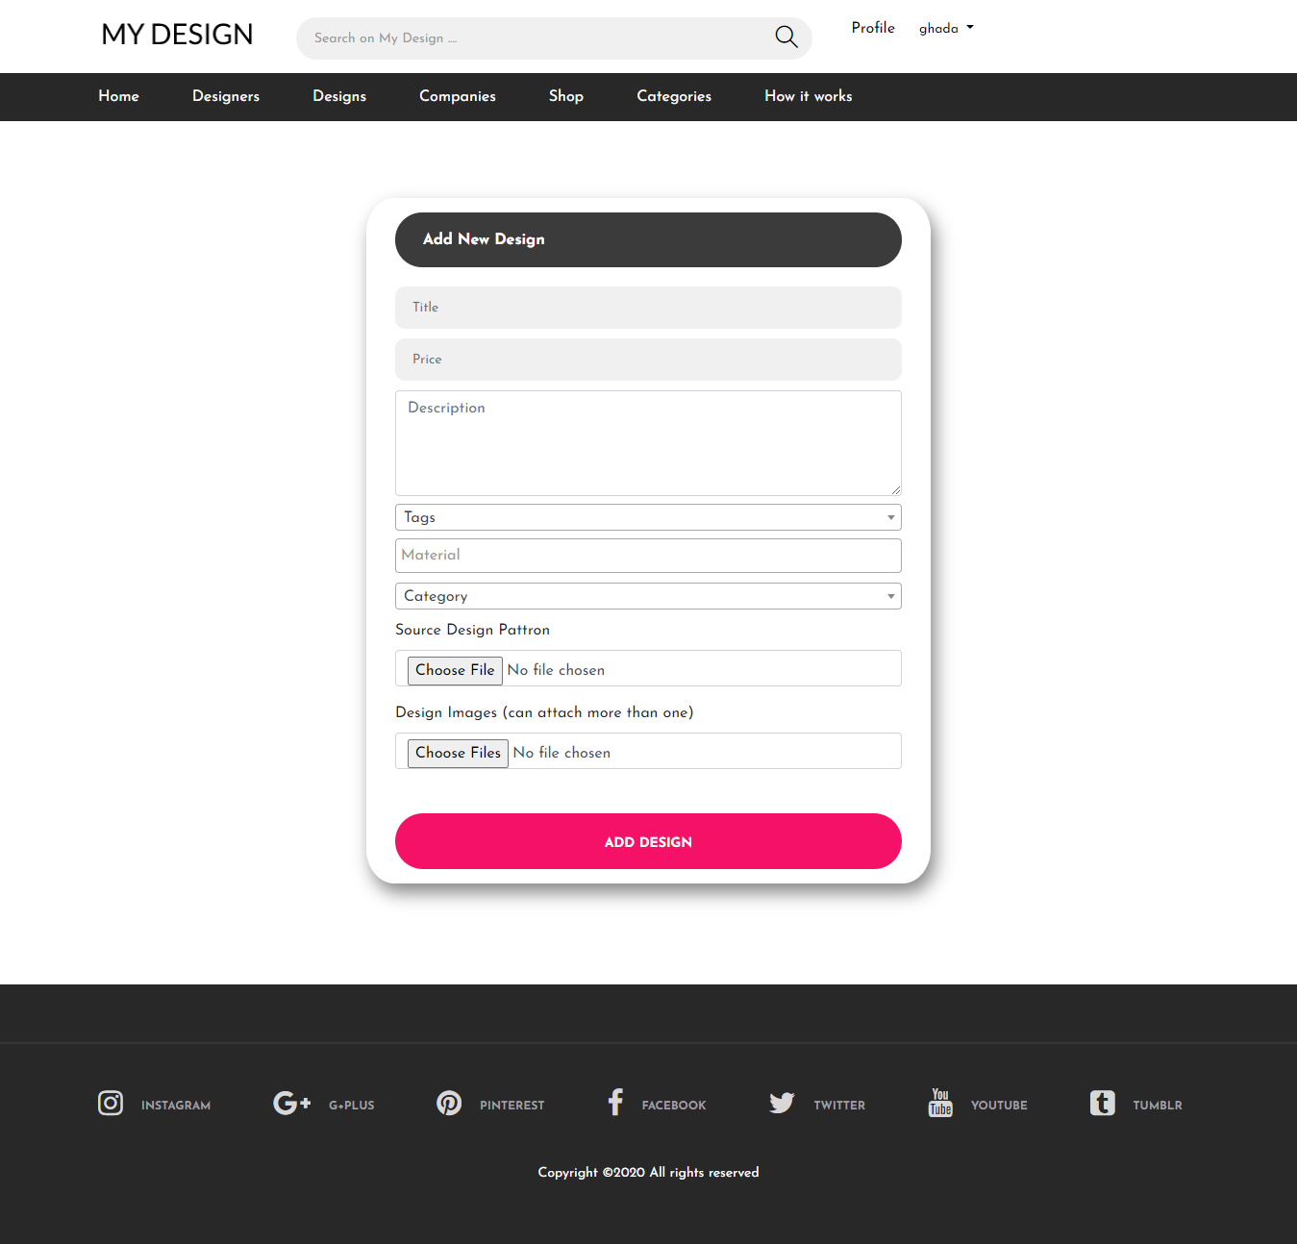

The designer select the category, tag and material for the design and provide images for user and soft copy for the companies who wants to buy the design

**Designer Profile**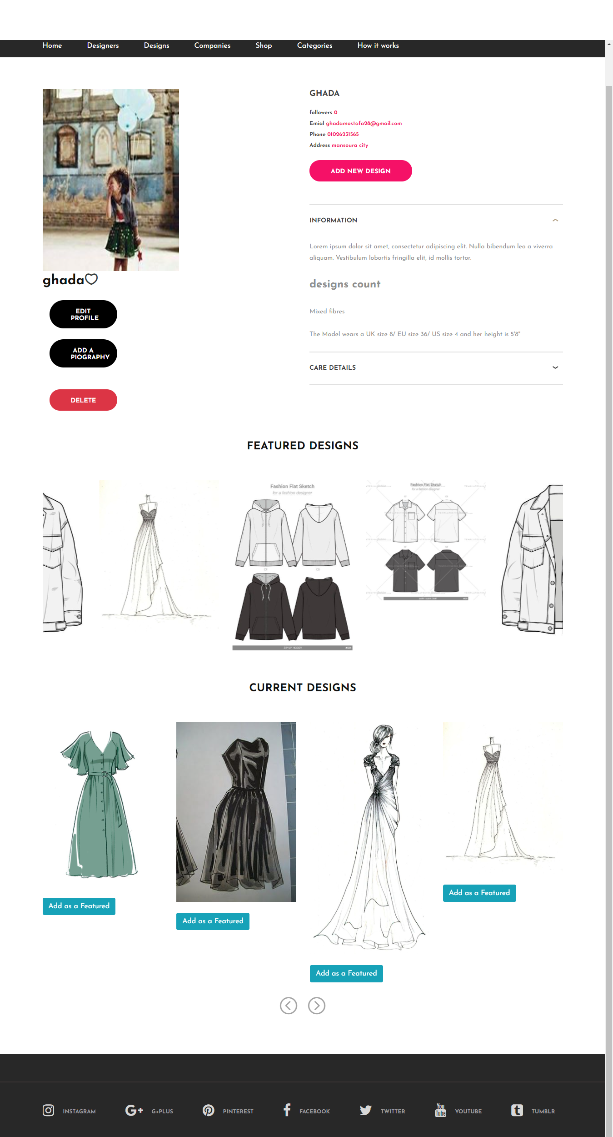

A designer can

* View his information
* Update his profile
* Add new design
* View his current work
* Add a design as a featured design
* View his previous work

**User Profile**

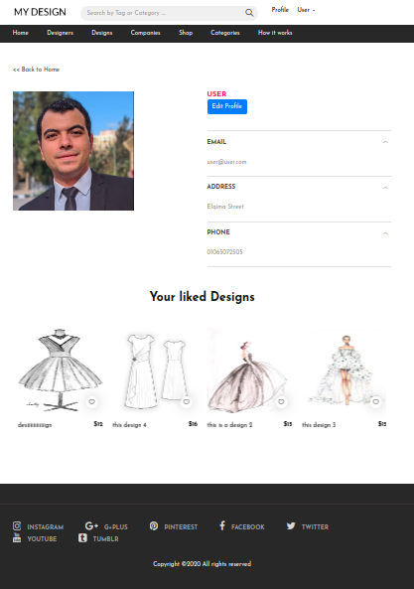

User Can

* View his information
* Update profile
* View liked design
* Can track liked designs

**Designs**

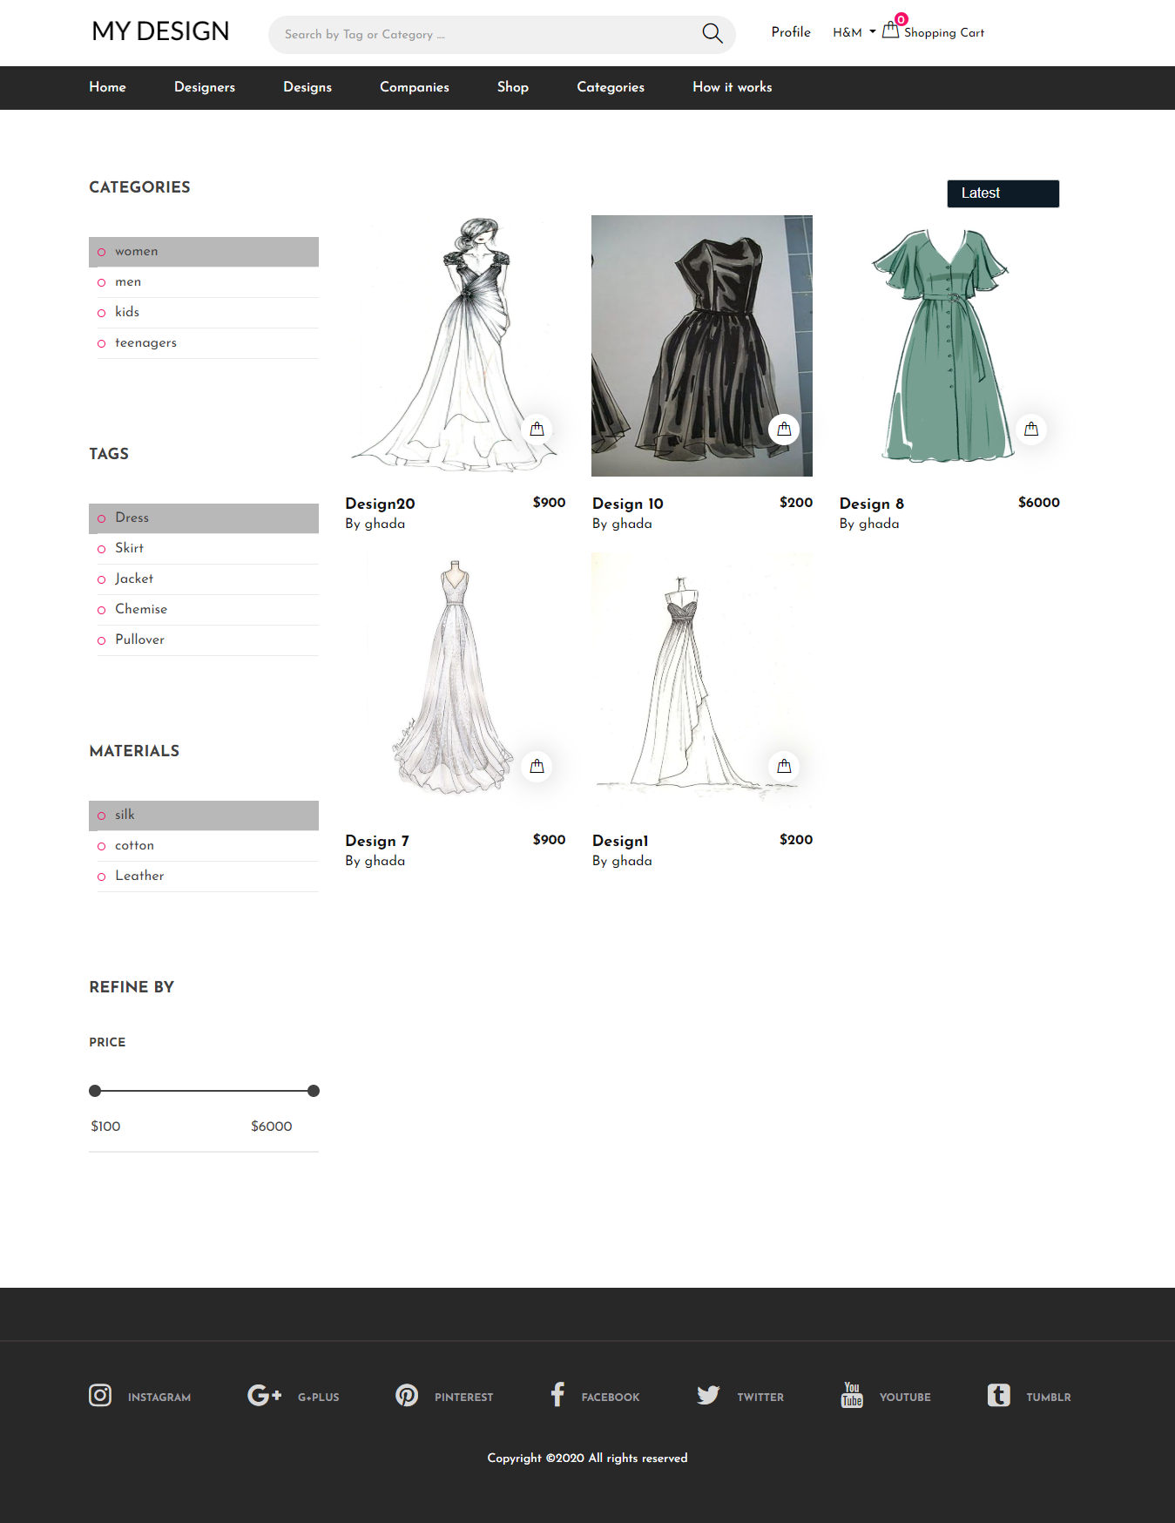

List all Designs in the website where you can filter them by price,category,material ,tag ,rate and latest designs.

**Design Details**

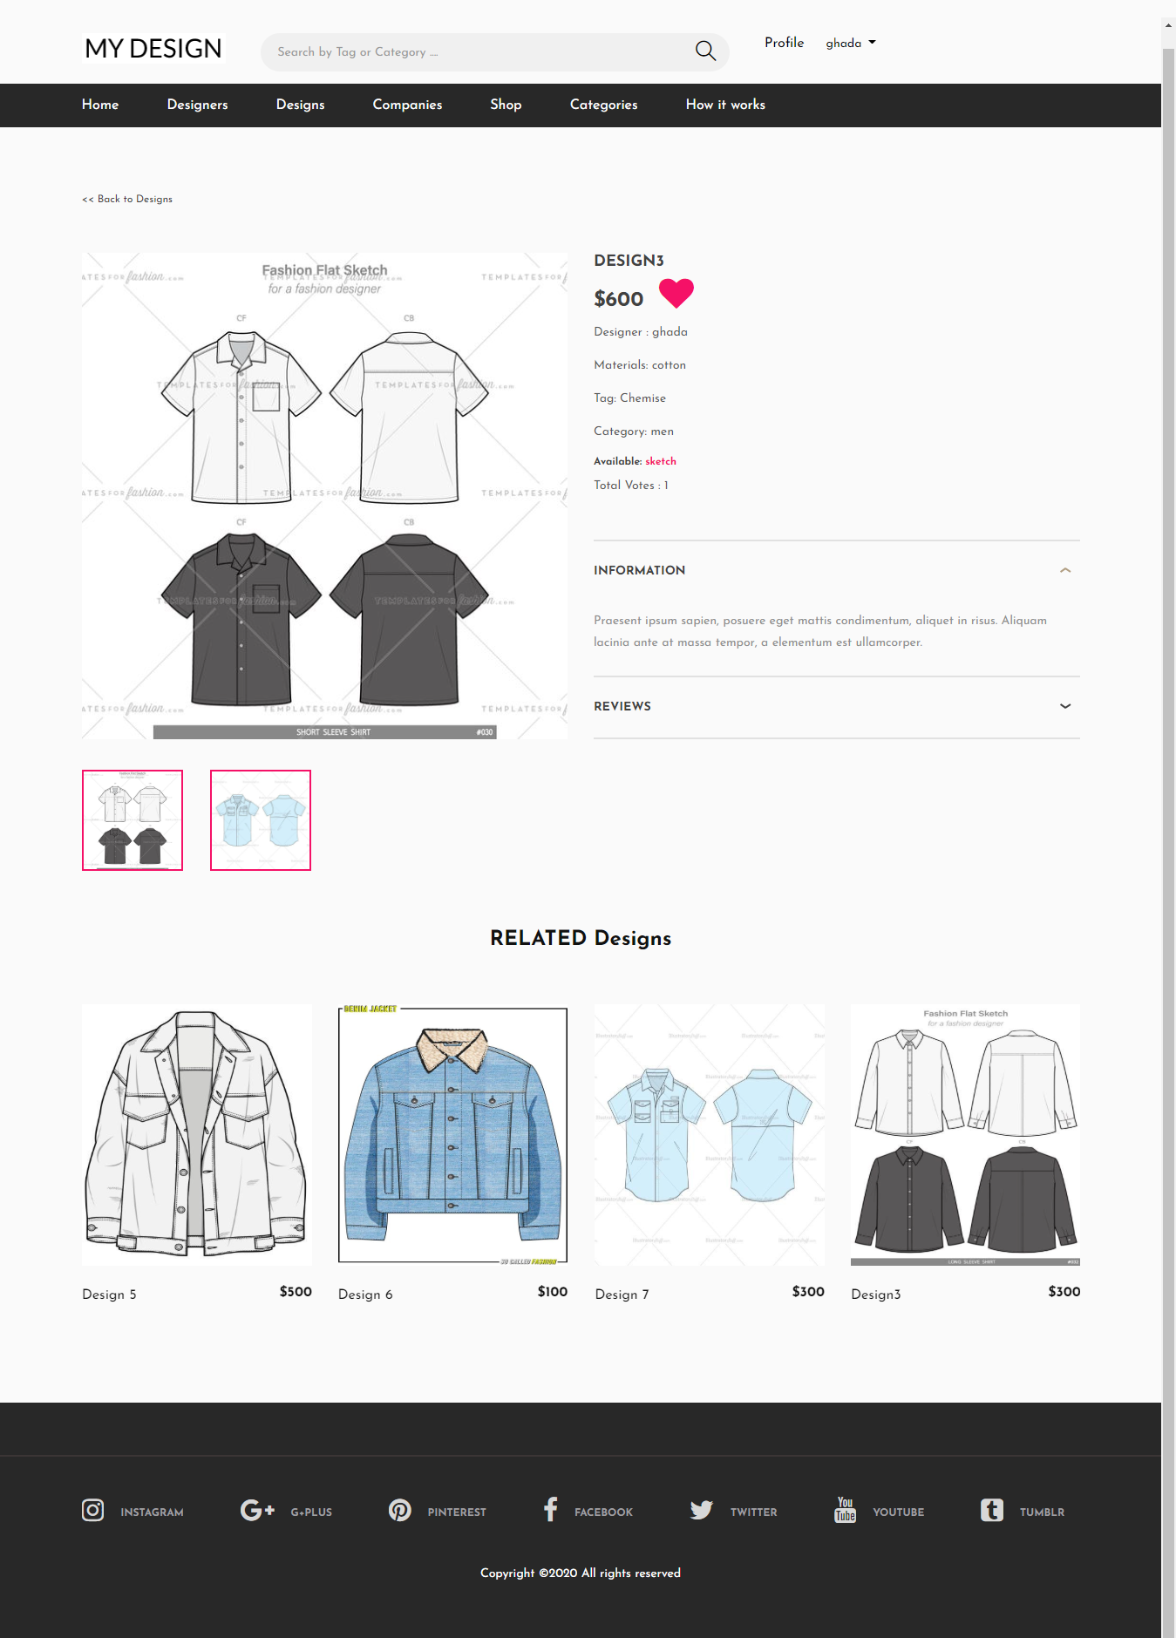

Design details page shows the design Information and related designs.

* As a designer who has created the design you can update,delete the design and write a comment
* As a user you can vote the design and write a comment.
* As a company you can buy the design and write a comment.

**Shopping Cart**

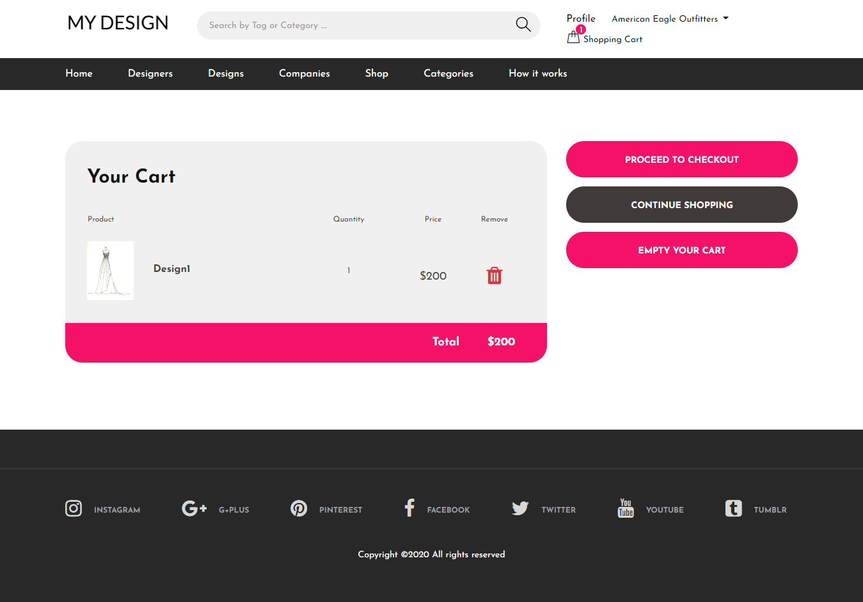

**Cart checkout**

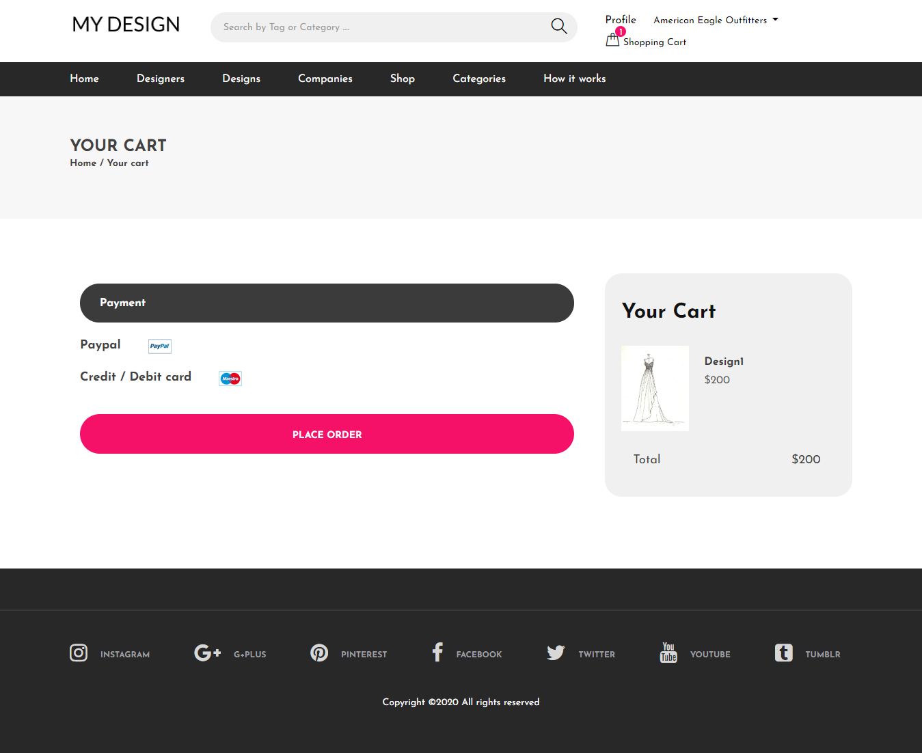

**Payment by credit card**

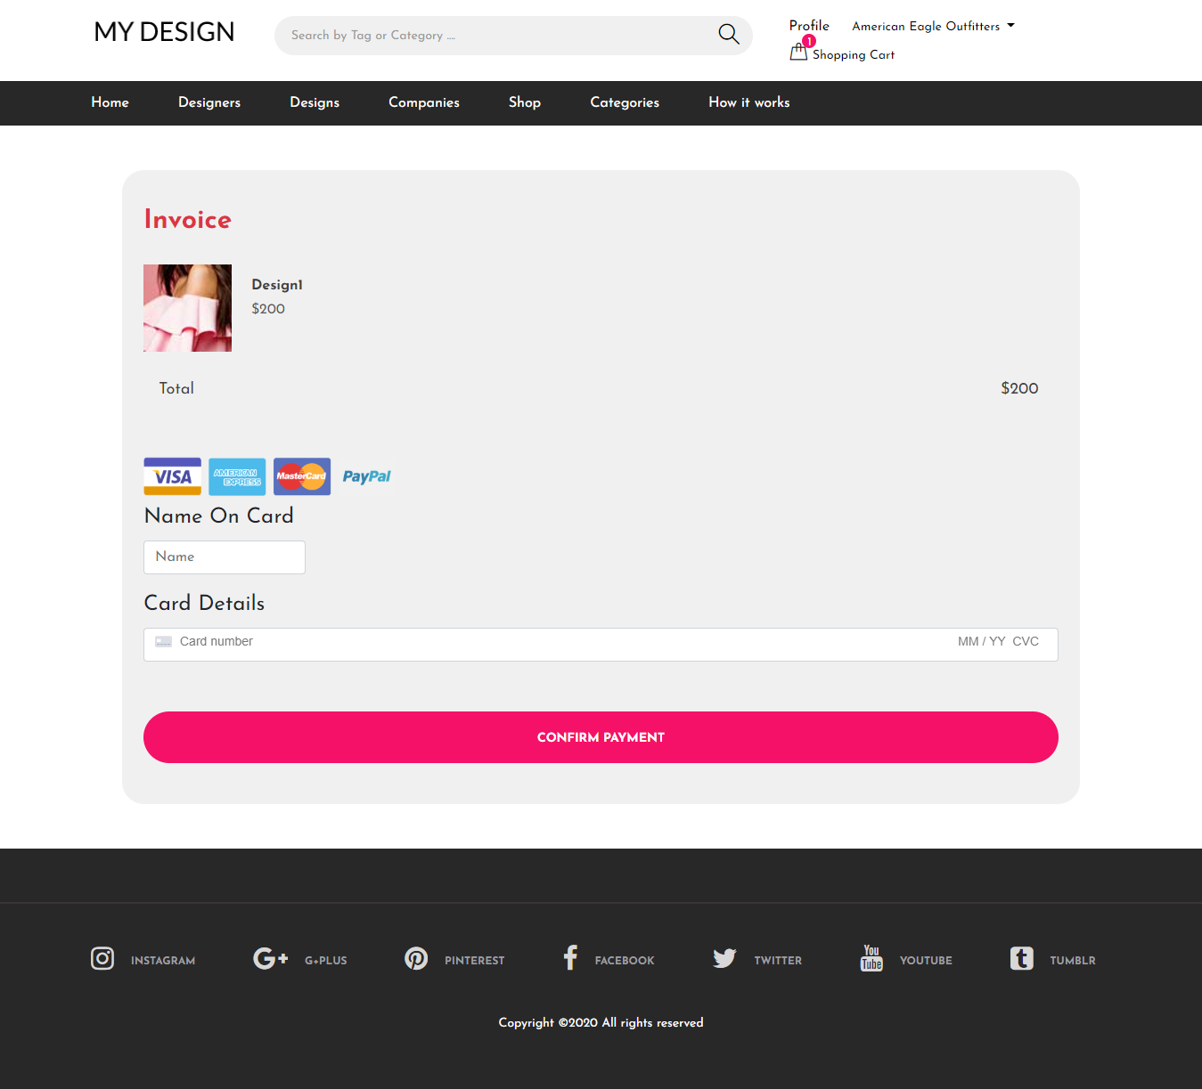

**Payment by paypal**

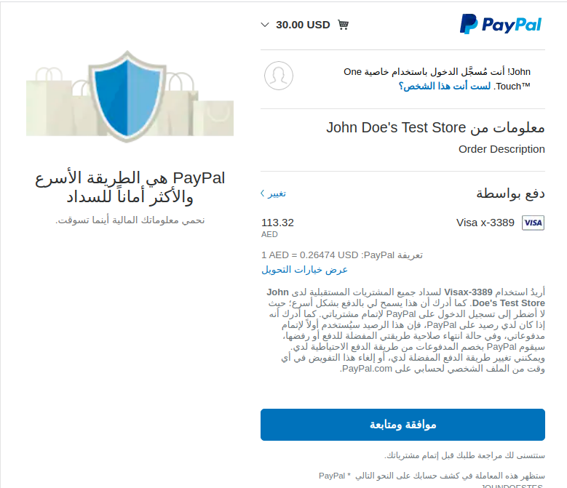

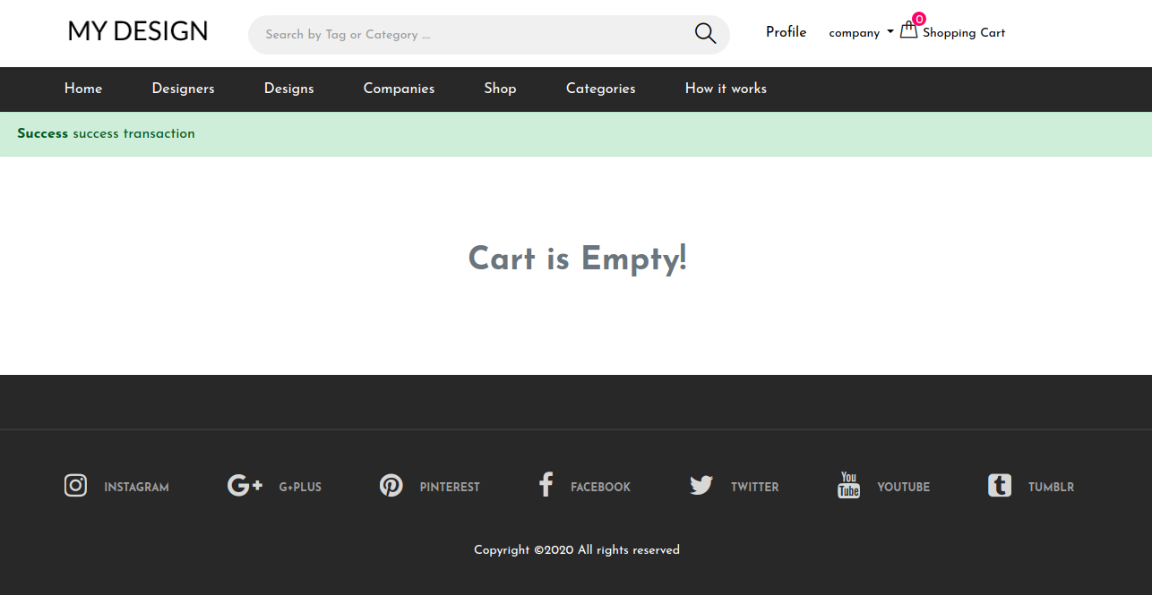

**Designers**

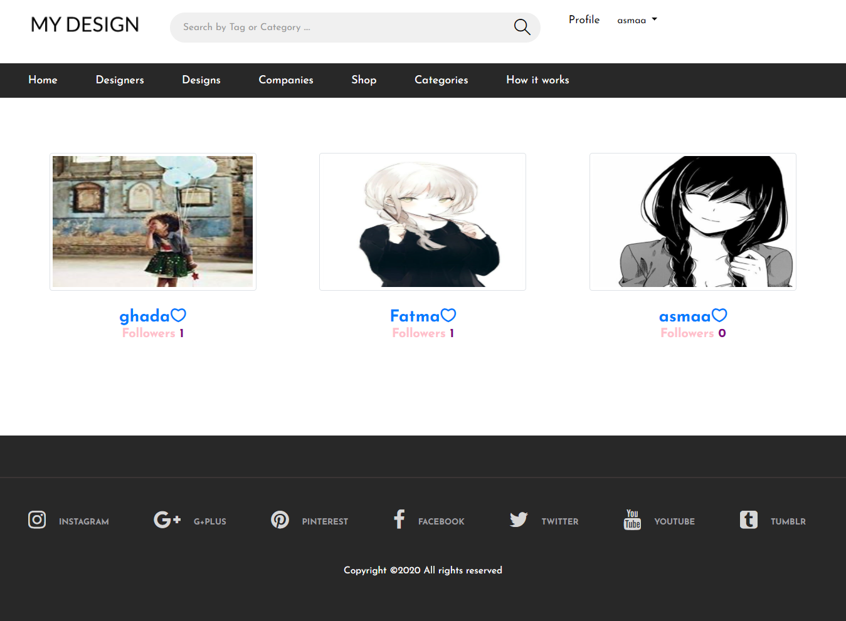

List all designers

* As a user you can follow a designer

**Company Profile**

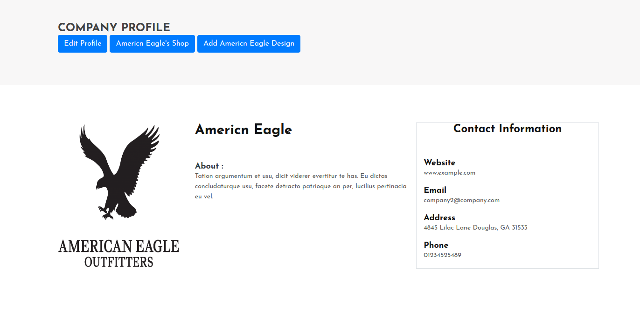

Company can

* View his information
* Update Profile
* View bought designs
* Upload made clothes
* Set state of the design as in progress,done

**Add Company Design**

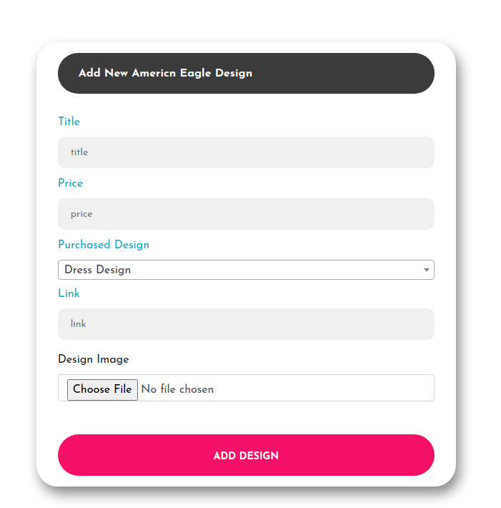

Company can

* Add new design
* Update existing design

**Company Shop**

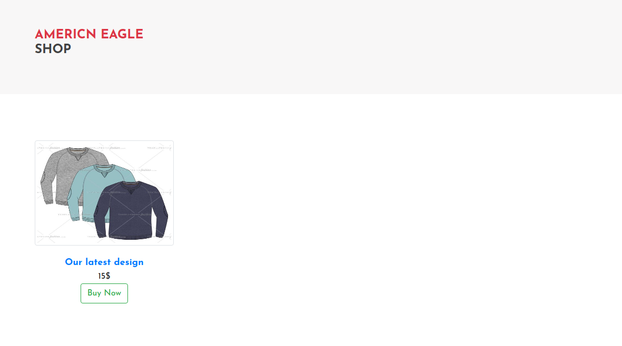

User can

* View the company designs
* Buy the design

**Our Companies**

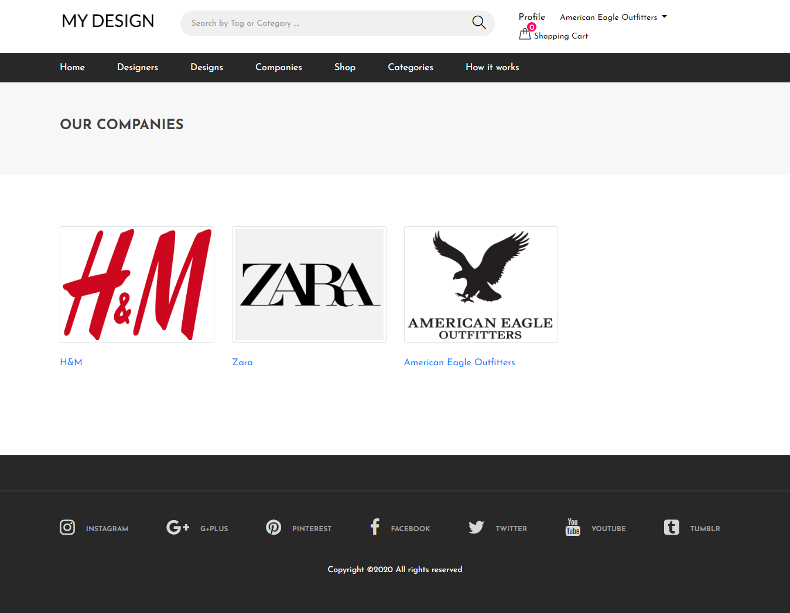

User can

* View our Companies
* Visit Company Profile